Department of Computer Engineering

**Academic Year: 2022-2023 Semester: VIII**

**Subject:-ADSL(CSL8023) Class / Branch / Division:**

**Name :- Roll Number:**

**Date :- Seat-no:-**

**Experiment no.**

**Aim** :Implement Karl Pearson’s coefficient of skewness

**THEORY**

Karl Pearson’s coefficient of skewness is a measure of the asymmetry of a probability distribution. It is based on the third standardized moment of the distribution and ranges between -1.5 and 1.5, with negative values indicating a left-skewed distribution, positive values indicating a right-skewed distribution, and 0 indicating a symmetrical distribution.

The coefficient of skewness is useful for understanding the shape of a distribution and for comparing distributions. For example, if we are comparing the distribution of test scores between two groups, we can calculate the coefficient of skewness for each group to see if one group has more extreme scores than the other. We can also use the coefficient of skewness to identify outliers in the data.

It is calculated as follows:

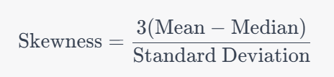

**CODE**

